Request for Quotes

Geotechnical Investigations

(Engineering and Construction Contract)

The Cook Islands Investment Corporation (CIIC) is seeking a suitably qualified and experienced Contractor to undertake site-specific geotechnical ground investigations in relation to two (2) proposed developments in Rarotonga, namely:

1. National Emergency Operations Centre, situated at the Office of the Prime Minister
2. Government House - the Official Residence of the Kings Representative

The Scope of works is contained in *Attachment 1.* Quotes shall be for the whole of the works and in accordance with the Contract.

|  |  |
| --- | --- |
| **Deadline for submission of Quotes:** | **4.00pm Wednesday 6 November 2024 (CI Time)** |
| **Indicative award notification:** | December 2024 |
| **Indicative contract delivery period:** | February 2025, approximately 2-3 weeks implementation duration, excluding mobilisation. |

**Quotes must be submitted by email to** [amber.numanga@cookislands.gov.ck](mailto:amber.numanga@cookislands.gov.ck)

# Conditions of Quotes

1. Contents of this RFQ

This RFQ consists of:

* Conditions of Quotes
* Attachment 1: Scope
* Attachment 2: Site Plans *(separate files)*
* Attachment 3: Site Information
* Attachment 4: Assessment Criteria
* Attachment 5: Response Forms
* Attachment 6: Draft Contract *(separate files)*
* Attachment 7: Bill of Quantities *(separate files)*

1. Communications regarding this RFQ

All correspondence and questions relating to this RFQ must be in writing via email and directed to the named Contact Person below.

Contact Person for this RFQ:

Amber Numanga

Asset Development Division

Cook Islands Investment Corporation

Email address: [amber.numanga@cookislands.gov.ck](mailto:amber.numanga@cookislands.gov.ck)

During the RFQ period, respondents must not contact any CIIC staff member in relation to this RFQ, or any other person associated with the RFQ, other than the person listed above. Unauthorised contact may invalidate you from the RFQ process.

1. Registrations of Interest

Prospective respondents should register their interest to participate in this RFQ process by emailing the Contact Person.

Only registered respondents will receive notices to this RFQ directly, if or when issued. It is the responsibility of the respondent to ensure they are properly registered for this RFQ.

1. Notices to this RFQ

Notices to this RFQ, if/when issued, will be distributed by email to registered respondents and uploaded to the E-Government procurement portal and CIIC Website.

1. Quote contents

Quotes must comprise of completed **Response Forms** – Refer to Attachment 3. Respondents may submit additional information in support of their Quote.

All Quotes must be firm offers and may not be withdrawn for a period of 60 calendar days following the deadline for submission of Quotes.

CIIC requires that all Quotes conform to these *Conditions of Quotes*, and reserves the right to reject any non-conforming Quote.

1. Submission of Quotes

Quotes must be received by the deadline specified on the front page of this RFQ. Quotes received after the deadline will not be considered.

Quotes must be submitted in electronic format only, in pdf format (or otherwise in a format compatible with Microsoft Office).

**Quotes must be submitted by email to** amber.numanga@cookislands.gov.ck

1. Confidentiality

Respondents are advised that CIIC is subject to the Official Information Act 2008. Respondents should mark their Quotes “Commercial - In Confidence” if they wish to protect specific information. CIIC will treat all Quotes in confidence. CIIC cannot however guarantee that information marked as Commercial – In Confidence can be protected if CIIC receives a request for information under the OIA.

1. The RFQ Process

Each respondent shall examine, or be deemed to have examined, the Conditions of Quotes, Scope, Site Plans, Site Information, Assessment Criteria and draft Contract, and any other information supplied by CIIC via the E-Government portal, CIIC Website or email.

In submitting a Quote in response to this RFQ, the respondent accepts and agrees to be bound by these Conditions of Quotes.

Respondents may choose to carry out site visits before submitting a Quote, and in order to assess the technical and site constraints associated with the Scope. The cost of attending site visits, preparing and submitting a Quote shall be borne by the Respondent.

CIIC reserves the right to change, suspend, cancel or reissue this RFQ, or the contents of the RFQ documentation at any time.

CIIC shall have no liability for any information it provides, or for any cost or loss to any respondent, in the event that this RFQ is cancelled, suspended, changed or reissued.

CIIC reserves the right to negotiate without restriction with respondents after the close of the RFQ on any matter contained in the Quote, without disclosing this to any other person.

CIIC reserves the right to accept or reject any or all Quotes, at any time prior to any contract being awarded.

1. Evaluation of Quotes

Quotes will be assessed against the criteria outlined in Attachment 4: Assessment Criteria.

CIIC may request additional information from any respondent before accepting any Quote, or implement additional processes to evaluate the Quote.

Each respondent shall be notified in writing as to whether or not it has been selected as the preferred Respondent as soon as possible. No Quote shall be deemed to be accepted unless and until the respondent has been notified by CIIC in writing.

CIIC reserves its absolute discretion in the evaluation and selection process.

1. Subject to Contract

Quotes are submitted on the basis that no binding legal relations with CIIC are created unless and until a formal written contract is signed by both CIIC and the successful respondent.

The acceptance by CIIC of any Quote, whether with or without negotiation, or the negotiation with an unsuccessful respondent, shall not create binding legal relations between CIIC and the party whose Quote has been accepted or which is negotiating with CIIC.

If, in the opinion of CIIC, and at CIIC’s sole discretion, none of the Quotes submitted are acceptable, CIIC reserves the right to enter into negotiations with one or more of the respondents for a satisfactory offer.

1. Governing law

Cook Islands law and the Cook Islands courts have exclusive jurisdiction over all matters relating to this RFQ govern this RFQ.

1. Contract Negotiations

Both parties agree to negotiate in good faith, and on successful conclusion of   
negotiations the preferred Respondent will sign a formal contract with CIIC.

The contract may be extended if additional work is required, at CIICs sole discretion.

1. Non-Resident businesses

In order for foreign companies to carry out business in the Cook Islands, they must be registered with the Business Trade Investment Board (BTIB). Should the successful Contractor be a foreign enterprise, they will be required to apply to BTIB to obtain the necessary approvals. Any fees associated with the registration must be paid by the successful Contractor. Respondents should inform themselves of the Foreign Enterprise Short Term Business Registration process. Information can be found online at [www.btib.gov.ck](http://www.btib.gov.ck).

Foreign workers must obtain visas from the Cook Islands Ministry of Foreign Affairs and Immigration prior to travel to the Cook Islands. Information can be found online at [www.mfai.gov.ck/immigration](http://www.mfai.gov.ck/immigration)

1. Cook Islands Tax Laws

Respondents should inform themselves of the Cook Islands tax laws including Value Added Tax (VAT) applicable to businesses registered in the Cook Islands, and non-resident withholding taxes applicable to foreign businesses for services delivered externally of the Cook Islands.

Attachment 1: Scope

This document forms the *Scope* under **NEC4 Engineering and construction short contract**.

# 1 Description of the *works*

### 101 Project objectives

Site-specific ground investigations are required in relation to two (2) proposed developments in Rarotonga, namely:

1. National Emergency Operations Centre, situated at the Office of the Prime Minister
2. Government House - the Official Residence of the Kings Representative

The *Client* has engaged Geologix Consulting Engineers NZ (Geologix) as the Geotechnical Professional. Geologix will produce the Geotechnical Investigation Reports (PIRs) to enable the Client to undertake preliminary and detailed designs for the above-mentioned developments. Geologix will supervise the ground investigations and will be responsible for field logging.

The *Contractor* (selected from this RFQ process) will undertake ground investigations at each of the proposed development sites, in line with the requirements stated in the following sections. The results of the *Contractors* investigations will inform the PIRs.

### 102 Description of the Works

The *Contractor* will undertake the drilling, in-situ testing and backfill/installation work stated in the following schedules and attached Site Plans – ***refer to RFQ Attachment 2*** *for the site plans.*

## Site 1: National Emergency Operations Centre

**Schedule of Investigation Locations (Site 1)**

| Location ID (eg BH number) | Method (NZGS Specification Clause*) | Size / diameter | Target depth (m) | In-situ testing | Sampling | Backfill / installation | Access restrictions and other specific instructions |
| --- | --- | --- | --- | --- | --- | --- | --- |
| MBH01 | Machine Cored (6.2) | HQ | 20 | SPT @ 1.5 m centres | NA | 32 mm diameter standpipe piezometer | Subject to confirmation. Access from 6am-10am in the morning. No access from 10am-2pm. 2:30pm-5pm access in the evening. |
| MBH02 | Machine Cored (6.2) | HQ | 20 | SPT @ 1.5 m centres | NA | 32 mm diameter standpipe piezometer | Subject to confirmation. All Day Access |
| MBH03 | Machine Cored (6.2) | HQ | 20 | SPT @ 1.5 m centres | NA | Backfill with bentonite pellets | Subject to confirmation. Access from 6am-10am in the morning. No access from 10am-2pm. 2:30pm-5pm access in the evening. |
| CPT01 | Cone Penetration Test (10.1 and 12.2) |  | 20 | Seismic and Dissipation test | NA | Backfill with bentonite pellets | Subject to confirmation. All day access |
| CPT02 | Cone Penetration Test (10.1 and 12.2) |  | 20 | Seismic and Dissipation test | NA | Backfill with bentonite pellets | Subject to confirmation. Access from 6am-10am in the morning. No access from 10am-2pm. 2:30pm-5pm access in the evening. |
| CPT03 | Cone Penetration Test (12.2) |  | 20 | None required | NA | Backfill with bentonite pellets | Subject to confirmation. All day access |
| CPT04 | Cone Penetration Test (10.1 and 12.2) |  | 20 | Seismic and Dissipation test | NA | Backfill with bentonite pellets | Subject to confirmation. All day access. |

**Reinstatement Requirements (Site 1)**

|  |  |
| --- | --- |
| Location ID  (eg BH number) | Reinstatement requirements |
| MBH01 | Install well cover flush with ground level set in concrete. Remove all litter and debris. Vacuum extract flush/ cuttings. Reinstate any damage, as required. |
| MBH02 | Backfill with bentonite to 0.3 m bgl and finish with existing surface covering. Remove all litter and debris. Vacuum extract flush/ cuttings. Reinstate any damage, as required. |
| MBH03 | Install well cover flush with ground level set in concrete. Remove all litter and debris. Vacuum extract flush/ cuttings. Reinstate any damage, as required. |
| CPT01 | Backfill with bentonite to 0.3 m bgl and finish with existing surface covering. Remove all litter and debris. Vacuum extract flush/ cuttings. Reinstate any damage, as required. |
| CPT02 | Backfill with bentonite to 0.3 m bgl and finish with existing surface covering. Remove all litter and debris. Vacuum extract flush/ cuttings. Reinstate any damage, as required. |
| CPT03 | Backfill with bentonite to 0.3 m bgl and finish with existing surface covering. Remove all litter and debris. Vacuum extract flush/ cuttings. Reinstate any damage, as required. |
| CPT04 | Backfill with bentonite to 0.3 m bgl and finish with existing surface covering. Remove all litter and debris. Vacuum extract flush/ cuttings. Reinstate any damage, as required. |

## Site 2: Government House

**Schedule of Investigation Locations (Site 2)**

| Location ID (eg BH number) | Method (NZGS Specification Clause*) | Size / diameter | Target depth (m) | In-situ testing | Sampling | Backfill / installation | Access restrictions and other specific instructions |
| --- | --- | --- | --- | --- | --- | --- | --- |
| MBH01 | Machine Cored (6.2) | HQ | 10 | SPT @ 1.5 m centres | NA | 32 mm diameter standpipe piezometer | Subject to confirmation. All day access |
| CPT01 | Cone Penetration Test (10.1 and 12.2) |  | 10 | Seismic and Dissipation test | NA | Backfill with bentonite pellets | Subject to confirmation. All day access |
| CPT02 | Cone Penetration Test (12.2) |  | 10 | None required | NA | Backfill with bentonite pellets | Subject to confirmation. All day access |
| CPT03 | Cone Penetration Test (12.2) |  | 10 | None required | NA | Backfill with bentonite pellets | Subject to confirmation. All day access |

**Reinstatement Requirements (Site 2)**

|  |  |
| --- | --- |
| Location ID  (eg BH number) | Reinstatement requirements |
| MBH01 | Backfill with bentonite to 0.3 m bgl and finish with existing surface covering. Remove all litter and debris. Vacuum extract flush/ cuttings. Reinstate any damage, as required. |
| CPT01 | Backfill with bentonite to 0.3 m bgl and finish with existing surface covering. Remove all litter and debris. Vacuum extract flush/ cuttings. Reinstate any damage, as required. |
| CPT02 | Backfill with bentonite to 0.3 m bgl and finish with existing surface covering. Remove all litter and debris. Vacuum extract flush/ cuttings. Reinstate any damage, as required. |
| CPT03 | Backfill with bentonite to 0.3 m bgl and finish with existing surface covering. Remove all litter and debris. Vacuum extract flush/ cuttings. Reinstate any damage, as required. |

### 103 General requirements

The *Contractor* will be responsible for making the following arrangements and settling all costs associated with:

1. Business registration (for foreign businesses) with the Business Trade Investment Board (BTIB).
2. Obtaining and maintaining insurances as required by the contract, specifically:
   1. For loss of or damage to property (except the works, Plant and Materials and Equipment) and liability for bodily injury to or death of a person (not an employee of the *Contractor*) arising from or in connection with the *Contractor* providing the works, minimum amount of cover for any one event: $2,000,000
   2. For death of or bodily injury to employees of the Contractor arising out of and in connection with the contract, minimum amount of cover for any one event: $200,000
   3. For the Contractors Plant, Equipment and Motor Vehicles, no minimum.
3. Preparing the Site-specific Health and Safety plan including task method statements, risk assessments, Job Safety Analysis (JSA) prior to any works commencing on the site;
4. Procuring and delivering all materials to the *Site(s)* and ensuring these remain secure throughout the works duration;
5. Supplying water, fuels and lubricants as needed;
6. Providing temporary power if required to complete the Scope and obtaining necessary permits;
7. Managing the *Contractor’s* work including contract administration, site and off-site activities,
8. Controlling health, safety and environmental management of the *Site*(s), and taking all practical steps to make the site and working environment safe;
9. Providing all tools, equipment, plant, machinery and operators, and technical expertise to complete the works;
10. Shipping, marine insurance, wharfage, export and import clearances for imported items;
11. Transporting goods between sites, and to/from the Avatiu Port;
12. Appointing a suitably qualified Site Manager to be based on the *Site*(s) during the execution of the works.
13. Settling all costs, whether direct or indirect, in respect of travel (and visas where applicable), accommodation, meals, daily allowances wages and/or salaries for the *Contractor* and the *Contractor’s* employees, agents and/or sub-contractors;
14. Provision of weekly progress reports to the *Client* on work completed and work yet to be completed, and attending weekly Site meetings;
15. Clearing of all debris, and maintaining a clean and tidy worksite at all times;
16. Reinstatement of the Site at the completion of the Works;
17. Delivering samples and cores to the *Clients* address (CIIC Yard is located off Takuvaine Road, Avarua); and
18. Attending to and rectifying all defects notified to the *Contractor* within the 6-week period following completion certification.

# 2 Drawings

The Site Plans are provided in Attachmnent 2 of this RFQ document.

# 3 Specifications

### 301 New Zealand Ground Investigation Specifications (NZGS)

In carrying out the work, the *Contractor* shall comply with the provisions of the NZGS Master Specifications, Volume 1. The schedules provided in *102 Description of Works* above makes reference to Methods and the corresponding clauses in the NZGS Master Specifications.

The *Contractor* must make all necessary allowances to comply with Clause 2 (General) of the Master Specifications, which may be over and above those explicitly stated in this Scope. Should the *Contractor* identify a potential inconsistency between this *Scope* and NZGS, direction must be sought from the *Client*.

### 302 Quality Management

All work shall be carried out in accordance with a quality management system(s) established in accordance with ISO 9001, ISO 14001, BS OHS 18001/ISO 45001 and AS/NZS4801.

### 303 Laws, regulations and standards

The *Contractor* is required by law to comply with all Cook Islands Acts, Regulations and Bylaws, including but not limited to the following:

* Environment Act 2003
* Employment Relations Act 2012

# 4 Constraints on how the *Contractor* Provides the *Works*

### 401 Restricted access to *Site*

Before commencing any work on a *Site*, the *Contractor* must cordon-off its immediate work areas so to not to allow public entry. The *Contractor* must monitor the *Site* for unauthorized access, and ensure orderly storage and security of all materials, plant or equipment when left unattended.

### 402 Use and possession of the *Site*

Both *Sites* will remain active and operational during the Contractors work. The control of the *Site* remains with the respective Government agencies. The *Contractor* will have sole possession of its immediate work areas only, which will shift from one location to another as the work progresses. The *Contractors* possession of the immediate work areas(s) is for carrying out the works only.

### 403 Working hours

Work on the *Site* is restricted to Monday to Saturday, between the hours of 7.30am and 7.30pm.

No work is permitted on Sundays.

Due to the nature of the operations on each Site, there will be instances when work will not be permitted due to the hosting of special events or Cabinet meetings. The *Contractor* should note that at least 1 day, generally mid-week, may be a no-work day (whole or partial day). The *Contractor* is advised make allowances for 5-day working week inclusive of Saturdays, to minimise disruptions.

### 404 Protection of Utility Services

Underground and overhead services must be protected from damage. Location of services must be carried out by the *Contractor* prior to works implementation.

The *Contractor* must report all damages to the *Client* immediately. The *Contractor* shall be liable for any damages caused because of the *Contractor’s* negligence.

### 405 Sourcing water

Due to low water pressure, the *Contractor* must arrange for the cartage of any and all water that may be required for the works. Arrangements can be made through a local supplier/contractor.

### 406 Environmental Protection

The *Contractor* must put in place all reasonably measures to prevent accidental spillage of fuel, or other hazardous materials. Proper waste management facilities and containment systems must be in place to eliminate pollution.

### 407 Code of Conduct

The *Contractor* and all personnel involved in the works shall adhere to the Government of the Cook Islands Code of Conduct Policy. The policy can be downloaded from the following url: <https://www.psc.gov.ck/guidance/integrity-and-conduct>.

# 5 Requirements for the programme

The *Contractor* must provide a Programme of works for each Site, in gantt format, identifying the locations and respective planned start/end dates. The Programme must be approved by the *Client* prior to Work on the Site commencing. The *Clients* approval will be subject to prior consultations and consent of the affected Government Agencies operating on the *Site*.

The Programme must be updated if there are any material changes.

# 6 Services and other things provided by the *Client*

The *Client* is responsible for the following:

1. Resource consents (where applicable)
2. Landowner access permission
3. Neighbour / Stakeholder consultations

The following is not required:

* Traffic Management
* WorkSafe NZ Excavation notification
* Heritage NZ consent
* Iwi consultation

The *Client* will assist the *Contractor* in the following areas:

* Facilitating business registrations, work visas, land transport, and import clearances. Any outgoing costs shall be passed to the *Contractor* for payment.
* Location of underground utilities.

The *Client* will provide:

* Outdoor storage area for the Contractor’s shipping container(s) at the CIIC Yard, Avarua, Rarotonga.
* Office space and internet access at the Client’s premises.

Attachment 2: Site Plans

Refer to separate Drawing files 100 to 103.

Attachment 3: Site Information

# Site 1: National Emergency Operations Centre

## Site Description

Situated at the Office of the Prime Minister in Tutakimoa, Avarua, Rarotonga, Cook Islands.

The site is presented within a mixed commercial area to the north and east of the site and adjacent to residential developments to the west and south of the site. The site is legally described as Part Section 10 of a larger block described as Tutakimoa 10, a parcel of crown land. The site is within Lease Number 1095 and is irregular, roughly rectangular in shape, with a gross site area of approximately 7409 m2. The site setting is presented schematically as Figure 1 below.

The site includes two principal land uses, with approximately the eastern half of the site forming soft landscaping of the Te Atukura Grounds and the western half of the site forming the Office of the Prime Minister (OPM) compound which houses approximately ten OPM divisions within seven single storey structures.

Figure 1: Site Setting[1]

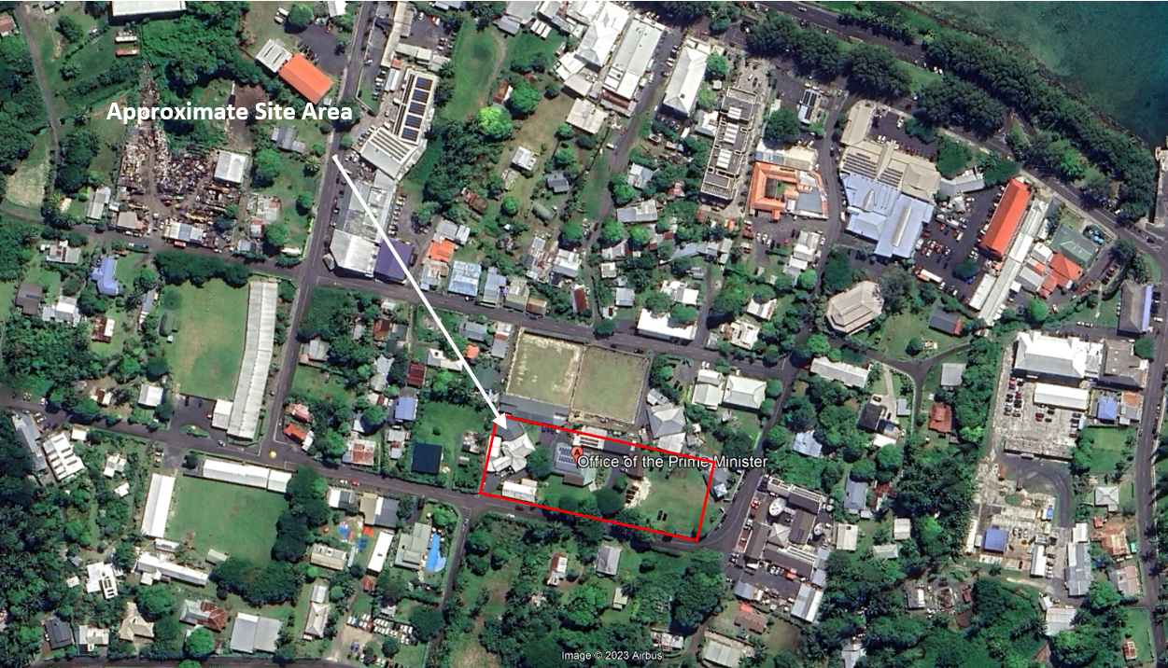

Topographically the site is situated over generally flat and level land with a slight dip to the north. Total elevation difference across the site is approximately 800 mm from 3.0 m above Mean Sea Level (MSL) along the southern boundary to approximately 2.2 m above MSL to the north-western corner of the site. A topographic survey of the site understood to have been commissioned in c. 2013 is reproduced in the Site Plans (Attachment 2 of this RFQ Document).

Multiple existing single storey structures exist on site. The existing structures are generally light-weight buildings with either timber clad or of concrete block/ limestone construction. A building annotated on the topographic survey along the northern boundary was demolished and cleared at the time of writing. Areas of internal roads and parking are generally formed from gravel hard fill with the balance of the site in soft landscaping including grassed surfaces and localised maintained gardens.

The site is accessed from Vakatini Road along the southern boundary through two existing vehicle crossings. However, only one vehicle crossing to the south-western corner of the site is available for use for the purpose of this ground investigation.

## Anticipated Geology and Ground Conditions

Available geological mapping[2],[3] indicates the site to be underlain by recent alluvial deposits described as Avarua Stony Loam. The unit is expected to comprise loosely consolidate mud, sand and gravel with variable strength and composition. At depth the material is expected to be underlain by coral deposits and in turn, volcanic flow material.

Areas of non-engineered fill are expected on the site with evidence of filling noted along the northern boundary of the property, elevating the site above surrounding swamp land.

## Existing Geotechnical Information

Existing geotechnical investigation reports were made available to Geologix at the time of writing. A summary is provided as Table 2.

Table 2: Summary of NZGD Available Records within 250 m

|  |  |  |  |  |  |  |
| --- | --- | --- | --- | --- | --- | --- |
| Record ID | Location  to site | Depth of  Borehole(s) | Depth to  groundwater | Depth  of fill | Depth of  Swamp Deposits | Depth of  Coral Deposits |
| AH1 – AH6 | ~300 m E | 20 – 42.5 m | 1.06 – 1.6 m | 1.2 – 3.6 m | NE – 3.6 m | 12.5 – 28.8 m |
| MB20/01 - /05 | ~300 m E | 19.5 –  40.0 m | Not Recorded | 1.9 – 3.5 m | NE – 2.6 m | >19.5 –  33.0 m |
| All depths in m below ground level unless stated otherwise.  NE – Not Encountered. | | | | | |  |

# Site 2: Government House

## Site Description

Situated in Titikaveka, Rarotonga, Cook Islands.

The site is presented within a coastal residential area to the north, east and west of the site and adjacent to Coastal Marine Area (CMA) beyond the Ara Tapu highway to the south of the site. The site is legally described as Arakua Part Section 34 and is roughly rectangular in shape with a gross site area of approximately 3,567 m2. The site setting is presented schematically as Figure 1 below.

The site is currently developed for a low-rise residential setting with an existing, single storey residential dwelling, outbuildings including a secretary of state office and two small sheds within the central northern half of the site. The balance of the site including a small strip to the north and east of the structures and the southern half of the site is generally presented as maintained gardens and soft landscaping with a single width gravelled driveway. The site is accessed at two points via the driveway to the south-western and south-eastern corners of the site.

Figure 1: Site Setting[4] 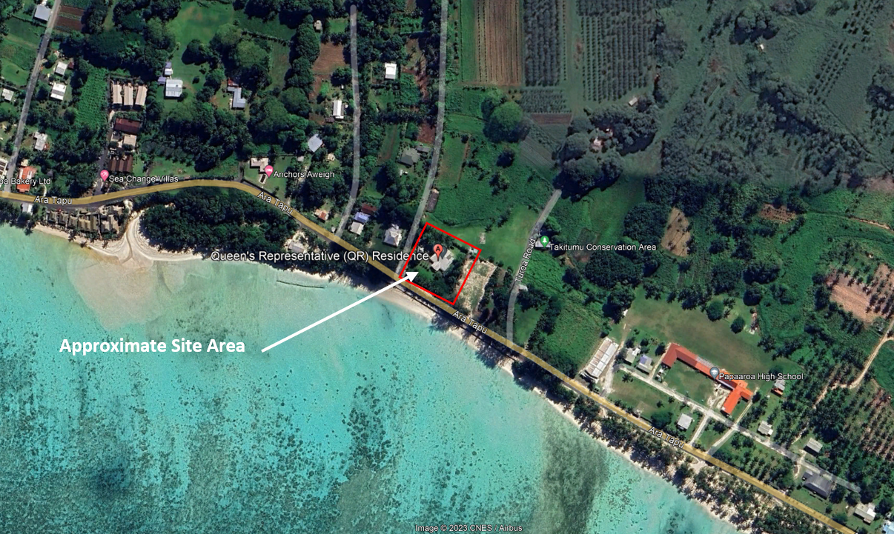

Topographically the site is situated over generally flat and level land with a slight dip to the southern boundary and ultimately the CMA beyond. Along the southern boundary, topographical survey indicates a level of approximately 2.8 to 3.15 m RL. However, specific vertical datum is not indicated. The level is generally consistent over the adjacent highway and connected to a sandy beach and coastal margin beyond by a rock spall grouted sea wall. It is understood the sea wall was recently upgraded due to inundation and erosion caused by king tides.

## Anticipated Geology and Ground Conditions

Available geological mapping[5],[6] indicates the site to be underlain by a veneer of granular alluvial deposits described as Muri Sand. The unit is expected to comprise beach and loosely consolidated deposits overlying coral at relatively shallow depths.

Towards and beyond the northern boundary of the property the geomorphology and geological mapping indicate swamp deposits described as Tamarua clay loam. This strata is typical over an inland strip around the northern, western and southern coastal margins of Rarotonga.

Areas of non-engineered fill are expected on the site with evidence of filling noted along the northern boundary of the property, elevating the site above surrounding swamp land.

## Existing Geotechnical Information

Existing geotechnical records including reports and/ or borehole logs were not provided at the time of writing. Little geotechnical information is known from this area of the Cook Islands.

Attachment 4: Assessment Criteria

|  |  |  |
| --- | --- | --- |
| No. | Assessment Criteria | Weighting (%) |
| 1 | Track record | 25% |
| 2 | Respondents competencies | 10% |
| 3 | Capacity of the Respondent to deliver | 25% |
| 4 | Price | 40% |
| Total | | **100%** |

Attachment 5: Response Forms

## Respondent Profile

**TIPS FOR COMPLETING THIS SECTION:**

• This section gives the Client basic information about your organisation and identifies your Point of Contact for the RFQ process.

• If an item is not applicable e.g. you do not have a registered office, complete the box by stating   
‘not applicable’.

# Our Profile

**Item Detail**

|  |  |
| --- | --- |
| **Trading name:** | [insert the name that you do business under] |
| **Full legal name (if different):** | [if applicable] |
| **Physical address:** | [put the address of your head office] |
| **Postal address:** | [e.g. P.O Box address] |
| **Registered office:** | [if you have a registered office insert the address here] |
| **Business website:** | [url address] |
| **Type of entity (legal status):** | [sole trader / partnership / limited liability company / other please specify] |
| **Company registration number:** | [if your organisation has a CI Company or NZBN registration number insert it here] |
| **Country of residence:** | [insert country where you (if you are a sole trader) or your organisation is resident for tax purposes] |
| **VAT registration number:** | [CI-VAT number] |

# Our Point of Contact

**Item Detail**

|  |  |
| --- | --- |
| **Contact person:** | [name of the person responsible for communicating with the Client] |
| **Position:** | [job title or position] |
| **Phone number:** | [landline] |
| **Mobile number:** | [mobile] |
| **Email address:** | [work email] |

# Our Insurance Details

**Item Detail**

|  |  |
| --- | --- |
| **Insurer:** | [name of current insurer] |
| **Insurance for:** | [state the insurance type i.e Public Liability] |
| **Limit of indemnity:** | [state the amount] |
| **Conditions:** | [state the conditions] |
| **Insurer:** | [name of current insurer] |
| **Insurance for:** | [state the insurance type i.e General Liability] |
| **Limit of indemnity:** | [state the amount] |
| **Conditions:** | [state the conditions] |

## Pricing Template

**TIPS FOR COMPLETING THIS SECTION:**

* **Complete and submit** the Bill of Quantities templates provided in Attachment 7. Refer to the “Instructions” tab in the Bill of Quantities for details.
* Insert the Section totals from the Bill of Quantities template into the Price List table below.
* All amounts are to be in New Zealand dollars.
* All amounts shall be exclusive of CI Value Added Tax (VAT). Where applicable, VAT will be paid with each payment claim.

# Price List

|  |  |  |
| --- | --- | --- |
| Item Number | Description | Price |
| National Emergency Operations Centre | | |
| 3 | Preliminaries |  |
| 4 | Machine Boreholes |  |
| 5 | Hand Tool |  |
| 6 | In-situ |  |
| 7 | Install |  |
| The total of the Prices (NEOC) | | NZ$ |
| Government House | | |
| 3 | Preliminaries |  |
| 4 | Machine Boreholes |  |
| 4 | Hand Tool |  |
| 6 | In-situ |  |
| The total of the Prices (Government House) | | NZ$ |
| The total of the Prices - combined | | NZ$ |

# Assumptions

State any assumptions you have made in relation to the cost and pricing information.

## Assessment Criteria

**TIPS FOR COMPLETING THIS SECTION:**

* These are questions relating to the Assessment Criteria (Attachment 4 of the RFQ). Your Quote will be scored against your answers to these questions. Aim to give answers that are relevant, concise and comprehensive.
* Attach supporting information where required.
* If you have made any assumption about the Scope or delivery, clearly state the assumption.

| 1. **Track record** | **Weighting 25%** |
| --- | --- |
| 1. Provide 3 examples of previous/current contracts you held/hold, demonstrating your ability to service the requirements of this contract. Include:  * the contract / name of client (including contact details for reference purposes), location of contract, and dates you provided the services * a brief description of the scope of works performed * a brief description of how you managed the delivery of the services to the client * a brief commentary of any specific experiences which is related or relevant to this contract   Note: We may conduct reference checks. Please ensure to inform Clients referenced here. | |
| [insert answer here] | |

| 1. **Respondents competencies Weighting 10%** |
| --- |
| 1. List the key people who will deliver the services, and their qualifications and experience (including any Biographies). Include the proposed Site Manager and operators. |
| [insert answer here |

| 1. **Capacity of the Respondent to deliver Weighting 25%** |
| --- |
| 1. Describe your methodology/approach to delivering the Scope. |
| [insert answer here] |
| 1. Describe how you intend to manage work outside of scope, i.e. additional minor works. |
| [insert answer here] |
| 1. Describe your organisation’s size, structure and annual turnover. Explain why this is sufficient to deliver the Requirements in full, on time, to high quality standards. |
| [insert answer here] |

## Statement of Departures from Contract Terms and Conditions

**TIPS FOR COMPLETING THIS SECTION:**

* If there are changes proposed to the Conditions of Contract, clearly state the Proposed Changes, relevant sections of the Conditions of Contract, and reasons for proposed changes.
* Leave section blank if there are no proposed changes.

|  |  |  |
| --- | --- | --- |
| **Proposed Changes to Contract:** | **Contract reference:** | **Justification:** |
| Example:  We propose that the fourth insurance be removed. The Tenderer confirms it will be liable for all costs that may be determined by the Cook Islands High Court. | Contract Data pg 3.  Insurance Cover 83.3 Fourth insurance “Death of or bodily injury to employees of the Contractor….” | We are unable to secure this type of insurance. We are insured under the Cook Islands Employers Liability Insurance through the Ministry of Internal Affairs. We comply with the Employment Relations Act 2012. |
|  |  |  |
|  |  |  |
|  |  |  |

## Alternative Proposals (Optional)

**TIPS FOR COMPLETING THIS SECTION:**

* In addition to a fully compliant Quote, Respondents may propose alternative methods that may result in cost efficiencies.
* This section is optional. Leave section blank if there are no proposed changes.

|  |  |  |
| --- | --- | --- |
| **Proposed Changes:** | **Justification:** | **Cost change:** |
|  |  |  |
|  |  |  |
|  |  |  |
|  |  |  |

## Conflict of Interest Declaration

A conflict of interest arises if you or a close family member has an interest e.g. is a board or committee member or is employed in a senior position in the Government agency that wants to purchase the goods or services relating to this RFQ process.

In submitting this Quote I declare:

* That I understand an actual, potential or perceived conflict of interest may arise in participating in this Quote process and that I am obliged to declare any such conflict of interest.
* That in submitting this information that I have either declared any potential conflicts of interest or that I am not aware of any situation or issue that would conflict with the interest of the CIIC.
* If a conflict of interest arises at any time before the selected Respondent has been awarded the contract, I will advise the CIIC immediately.
* I have personally completed this declaration on behalf of the Respondent and declare that the submitted Quotes provided are true and correct.

I declare that I have a potential conflict of interest as follows:

|  |  |  |
| --- | --- | --- |
|  | | |
|  | | |
|  | | |
|  | | |
|  | | |
| I will manage this conflict of interest by: | | |
|  | | |
|  | | |
|  | | |
|  | | |
| Declared by: | | |
| Signature |  | Date |
| Full Name |  | Position (if Company) |

Attachment 6: Draft Contract

The contract standard is **NEC4 Engineering and construction short contract**. The contract forms are provided as a “draft for reference only” and should not be filled in during this RFQ process.

Respondents should inform themselves of the draft provisions and conditions of contract. Should a Respondent propose amendments, such amendments should be listed in the Response Form.

Attachment 7: Bill of Quantities

Refer to separate BoQ excel files.

1. Source: Google Earth Pro.
2. New Zealand Geological Survey, Geologix of the Cook Islands, Wood, B.L. and Hay, R.F, 1970.
3. Lands and Survey Reconnaissance, Soil Map of Rarotonga Cook Islands, Grange, L.I. and Fox, J.P.
4. Source: Google Earth Pro.
5. New Zealand Geological Survey, Geologix of the Cook Islands, Wood, B.L. and Hay, R.F, 1970.
6. Lands and Survey Reconnaissance, Soil Map of Rarotonga Cook Islands, Grange, L.I. and Fox, J.P.